iion SDK-unity Integration

Step 1: Drag the aar under:/Assets/Plugins/Android/libs

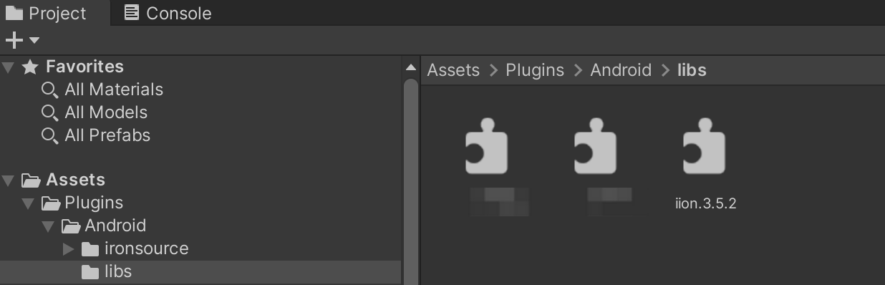

Step 2: Place the adapter code folder “ironsource” under /Assets/Plugins/Android/, shown as below:

